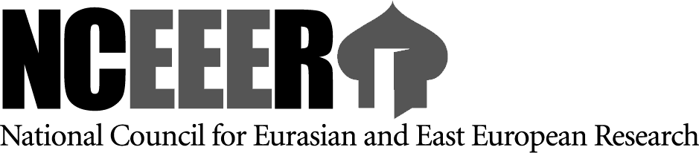



Carnegie Research fellowship program

Research Opportunities in the United States
For Scholars in the Humanities and Social Sciences

A Program of the National Council for Eurasian and East European Research (NCEEER)
In conjunction with the American Councils for International Education: ACTR/ACCELS
Supported by a Grant from Carnegie Corporation of New York

PROGRAM DESCRIPTION:
The National Council for Eurasian and East European Research is pleased to announce the competition for the Carnegie Research Fellowship Program in the United States for the 2016-2017 academic year. Scholars of the humanities and social sciences from eligible regions may apply for individual, non-degree research opportunities at universities and institutes in the United States. This competition selects university faculty, researchers, advanced graduate students, and scholars in the social sciences and humanities from Armenia, Azerbaijan, Belarus, Georgia, Moldova, Russia and Ukraine. All fellows will conduct research on specific topics in the social sciences and humanities, write a 15 to 30 page academic paper upon the fellow’s return home, and deliver lectures with the goal of contributing to the further development of higher education and scholarship in their regions. The Carnegie Research Fellowship Program (CRFP) is administered by the National Council for Eurasian and East European Research (NCEEER) in collaboration with the American Councils for International Education: ACTR/ACCELS (American Councils). Participants in the CRFP will conduct research in the United States for four months.
Participants in the CRFP will receive the following: 1) round-trip airfare from their home cities to their host universities in the United States; 2) a pre-departure orientation, and an orientation program in Washington D.C.; 3) a monthly stipend; 4) health insurance; and 5) access to libraries and archives, and alumni activities. Additionally, all CRFP scholars will be eligible for a scholar development fund to aid in purchasing books, technology, and other research tools, or to attend a conference and become affiliated with professional groups in the United States.
Awards for this program are contingent upon the availability of funding from the Carnegie Corporation of New York.

DEADLINE FOR SUBMISSION OF APPLICATIONS: documents should reach the office by 5 p.m. on April 30, 2016

ELIGIBILITY:

Individuals who are eligible to participate in CRFP:
- Citizens of Armenia, Azerbaijan, Belarus, Georgia, Moldova, Russia and Ukraine.
- Applicants whose proposals relate to the themes chosen by one of the Centers for Advanced Study and Education (CASE):
- European Humanities University, Center for Advanced Studies and Education on Social Transformations in the Western Eurasia Border Region -- Belarus, Moldova, and Ukraine.
- Caucasus Research Resource Centers (Baku, Yerevan, Tbilisi). The South Caucasus: Life in Transition.

- Advanced graduate students, university faculty and scholars at any stage in their careers who have not recently conducted research projects at U.S. institutions.
- Scholars who hold an equivalent of “Kandidatskaya” degree or higher, or who are working towards a “Kandidatskaya” degree at the time of application.
- Scholars who have a level of proficiency in written and spoken English that is sufficient to conduct independent research and engage colleagues.
- Scholars who have publications (advanced graduate students may cite papers presented at academic conferences) in a particular field.
- Scholars who are able to receive and maintain a United States J-1 visa.
- Scholars who are able to begin the CRFP in the United States in September 2016, or January 2017.
NCEEER and the American Councils do not discriminate on the basis of race, color, sex, religion, national or ethnic origin, handicap or disability.

Additional information available on http://www.nceeer.org (Carnegie Program), http://www.americancouncils.ge and via alexei@nceeer.org

Alexey Kharlamov
Senior Program Officer/Western NIS and South Caucasus
National Council for Eurasian and East European Research (NCEEER)
American Councils for International Education (ACTR/ACCELS)/
Georgia Office
35a Chavchavadze Avenue
Tbilisi Georgia 0162
Tel: +995 32 229 21 06
Fax: +995 32 225 21 07
alexei@nceeer.org
www.nceeer.org

